**Chandramohan –k 717821p112**

**WEEK-3**

4**. Promise, Promises chaining:**

Task 1: Create a new promise that resolves after a set number of seconds and returns a greeting.

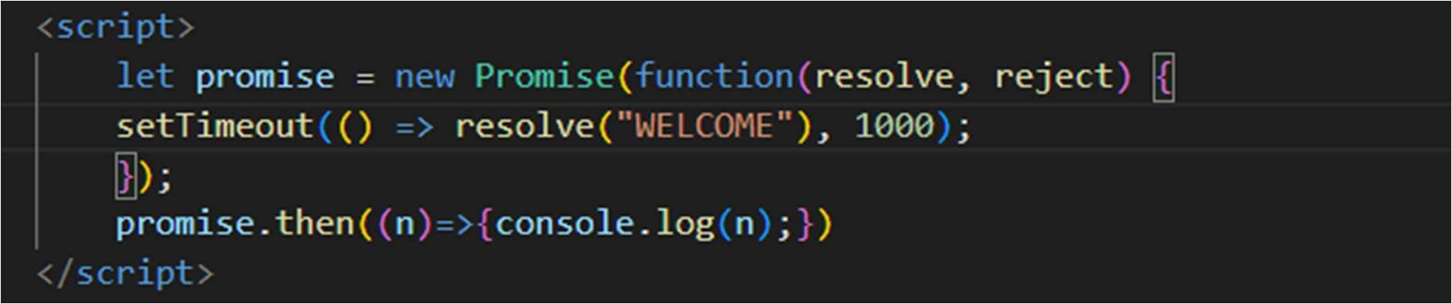

Task 2: Fetch data from an API using promises, and then chain another promise to process this data.

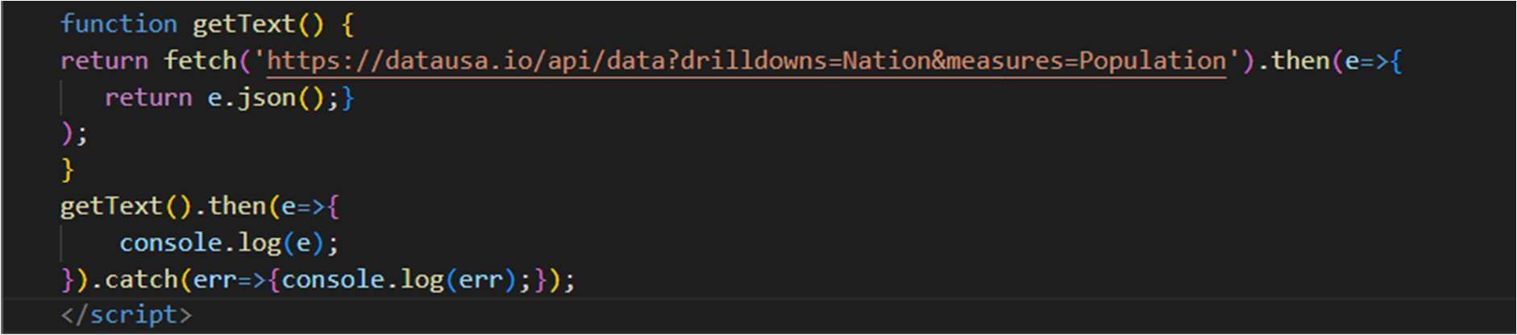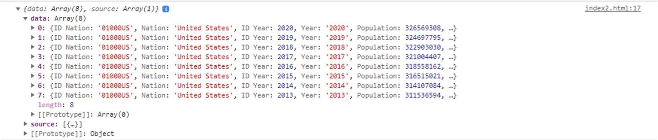

Task 3: Create a promise that either resolves or rejects based on a random number.

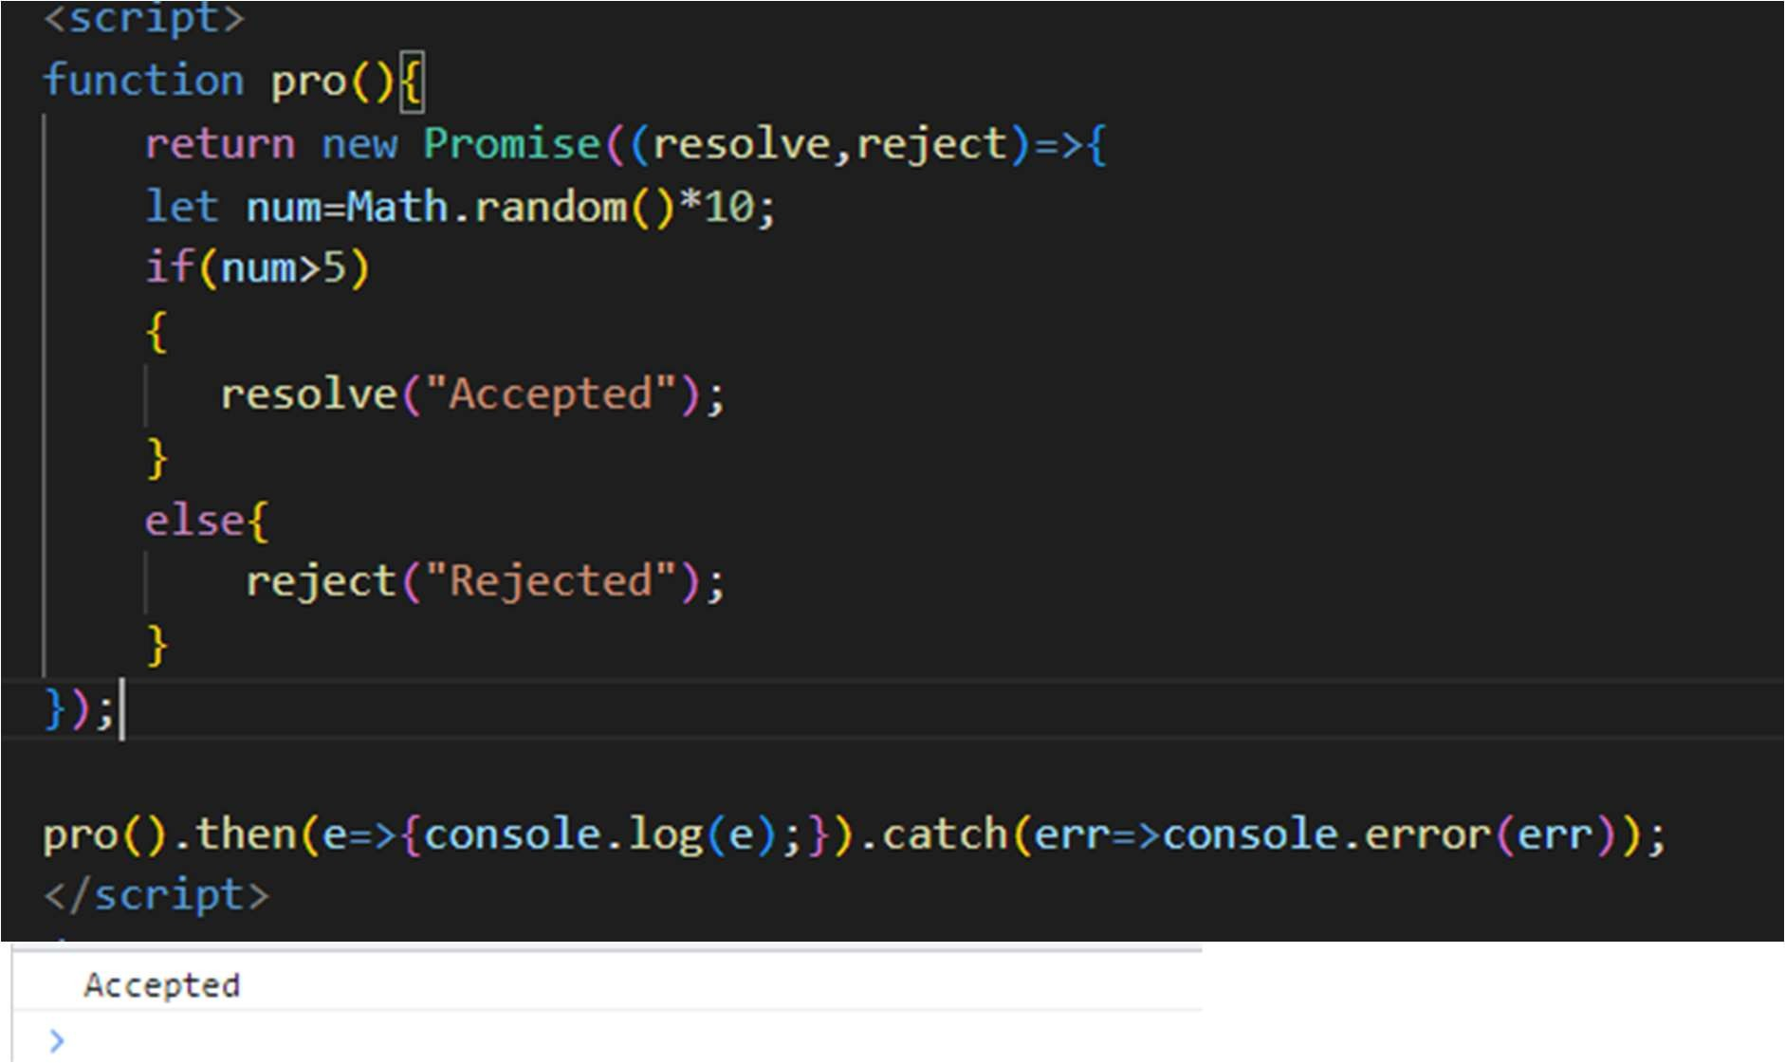

Task 4: Use Promise.all to fetch multiple resources in parallel from an API.

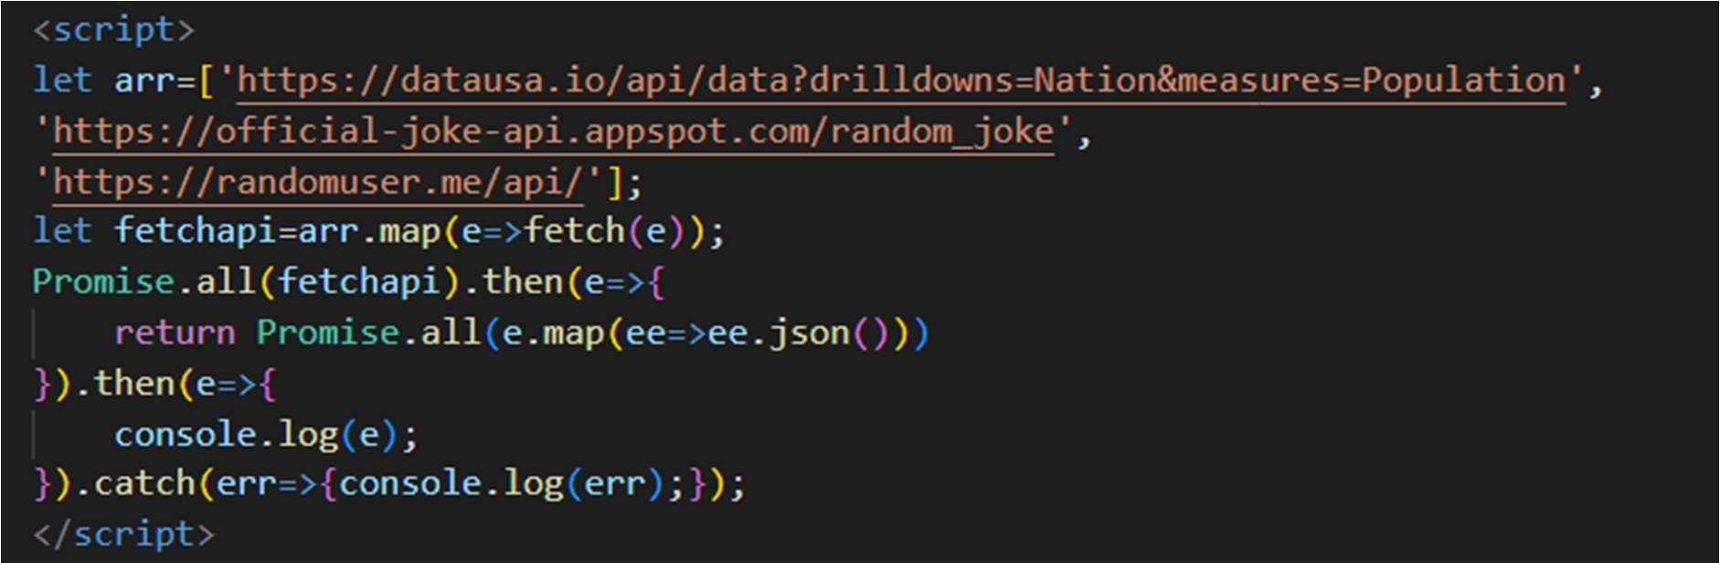

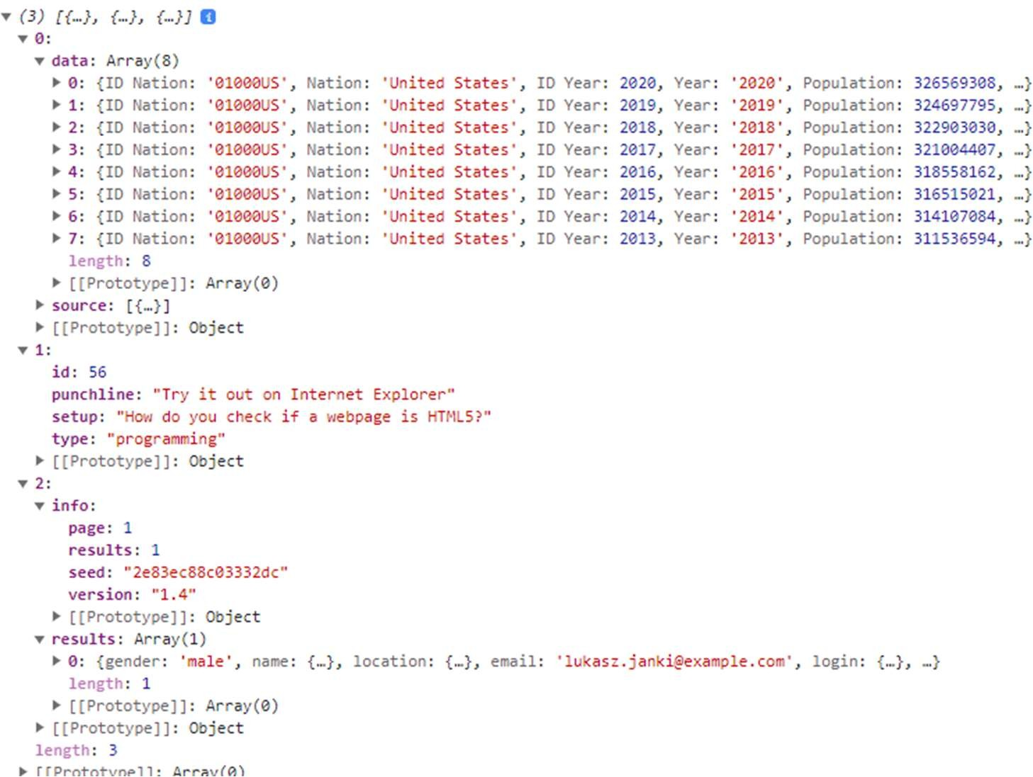

Task 5: Chain multiple promises to perform a series of asynchronous actions in sequence.

